Formulas for Paid Weeks Calculations:
To calculate the number of Paid weeks, data needed is:
A Employee Start Date
B Number of Actual Weeks Worked ( Contracted Weeks )
C Annual Leave Days based on length of service ( Less than 5 yrs, 5 to 10 yrs, More than 10 yrs )
(Includes 8 days Bank Holidays) | < 5 yrs | 5– 10 yrs | >10 yrs
At or below scp 24 ( to Grade F) | 34 | 38 | 41
Above scp 24 ( Grade G & above) | 36 | 41 | 43
Annual leave entitlements are pro rata’d for part time and term time employees

D Annual Leave Weeks ( Annual Leave Days divided by 5 = Annual Leave Weeks ( C/5 )
Formula ( B + B * D ) / ( 52.1492 – D ) = Paid Weeks

To calculate salary:
We need to calculate the Full Time Equivalent (FTE) for the role, based on 1.0 being the standard (employee working 37 hrs per week, 52 weeks a year )
The following data is needed:
E Paid Weeks ( using the table or the calculator )
F Hours Worked Per Week
G Salary as per Spinal Point Pay Scales
H FTE Factor
Step 1 Calculate the FTE Factor
Formula is: ( F / 37 ) x ( E / 52.1429) This gives us the FTE Factor ( H )
Step 2 Calculate Salary
G x H = Annual Salary. This can then be divided by 12 to give a monthly Gross.

Example:
Alison is a Senior Midday Supervisor
Start Date: 01 June 2013 ( more than 10 years service )
Actual weeks Worked : 38 Weeks
Hours worked per week: 8.00
Salary: Spinal Point 5 ( £23,500pa)
Paid Weeks: Alison was being paid at a rate of 44.4837 weeks per year
Upon analysis, it was identified that Alison should be paid at a rate of 45.0911 weeks ( due to her 10 years service ) . She was still being paid as if her service was 5 to 10 years.
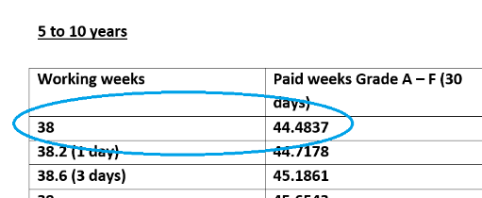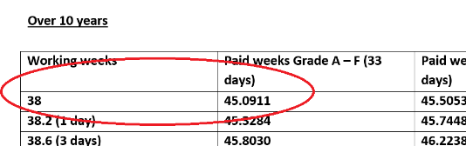

Calculate Current Salary:
Using the SAAF Payroll spreadsheets, the FTE Factor is already stated. For Alison it is: 0.184457
We take the FTE Factor and multiply this by the Spinal Point Salary
0.184457 x 23500 = £4,334.74 . This is the salary Alison receives currently each year. Divided by 12 is her monthly ( gross salary ) which is £361.23
Calculate Revised Salary
Firstly, we need to calculate the revised FTE Factor
Revised Paid Weeks: 45.0911
Hours worked per week: 8.00
Salary: £23,500
Formula
( 8 / 37 ) x ( 44.0911 / 52.1492) = 0.1869747 ( this is the revised FTE Factor )
Salary
The formula is the FTE Factor multiplied by the annual salary
0.1869747 x 23500 = £4,393.91 This is her revised salary. Divided by 12 is the monthly gross, which is £366.15
Difference
Current Salary minus Revised Salary
£361.23 - £366.15 = -£4.93 This is the underpayment amount per month.
Some of the underpayments will be larger than this figure, and some overpayments will also show a larger difference.
Potential backpayment
We know that Alison hit the 10 year service mark in June 2023 based on her start date. Therefore, the Revised Paid Weeks should be effective from that date. We have therefore 12 months of back payment due for Alison
£4.93 x 12 = £59.16 due

