Consultation with all City Schools

Schools Block Transfer for 2019/20

Launch date: Tuesday 17th July 2018

Closing date: Wednesday 19th September 2018

How to respond:

Consultation response forms are available on the schools extranet at: http://www.nottinghamschools.org.uk/business-management-support/schools-funding/consultations/

Completed forms must be saved and then sent by e-mail to: school.funding@nottinghamcity.gov.uk
(please include the word “Consultation” in the Subject Line of your email)

Consultation Briefing Event:

Thursday 6th September 8.30am Notts County 1862 Suite

Contents: Page

1. Executive Summary 3

2. Background information 4-5

2.1 High needs funding arrangements
2.2 Permanent exclusions and resultant budget pressure
2.3 Schools Block transfer regulations

3. Rationale 5-6

4. Proposals and implications 6-8

5. Longer term plan 8-9

Appendices:

Appendix A High needs funding diagrams 10

1.0 Executive Summary

Spend on the high needs budget currently exceeds the LA’s high needs funding allocation due to the high rate of permanent exclusions in the City and the ongoing costs of provision for pupils permanently excluded. The shortfall has been met in previous years from DSG reserves funding, but as reserves are fast being exhausted this is not a sustainable approach. Attempts to seek city wide sign up to a revised devolved funding model for secondary pupils at risk of exclusion which would have put the high needs budget on a secure long term footing have not been completely successful with 10 out of 17 City secondary schools agreeing to participate.

Due to this pressure on the high needs budget and the financial risks around exclusions in schools not signed up to the new model, the LA is seeking to transfer funding from the schools block to the high needs block in 2019/20. This involves funding schools at a lower level than they would otherwise have been. This option is available as a one-off in 2019/20 but may cease to be possible from 2020/21 under full implementation of a “hard” National Funding Formula for schools. By acting in 2019/20, we preserve the DSG reserve balance for future years when we will have lost this flexibility. The remaining DSG reserve balance will then be available for future pressures including on Alternative Provision (AP), thereby safeguarding existing support and provision for pupils with SEN.

We are consulting on a recommended Proposal A, which requires Secretary of State approval and a fall-back Proposal B which can be approved locally by Nottingham City Schools Forum.

Proposal A (recommended)

Only secondary schools are affected. Funding per pupil in the secondary phase would be cut by up to 1.5% per pupil in 2019/20. We would seek to reimburse schools signed up to the devolved AP model by up to 35% through additional devolved funding.

Proposal B

Proposal B is required as a fall-back option, in the event the Secretary of State does not give approval for treating primary and secretary schools differently. Under proposal B, all mainstream City schools would forego a funding increase of around 0.5% in 2019/20.

Schools are requested to respond by 19 September to the following questions:

- Do you support the principle of the LA seeking a schools block transfer in 2019/20 for the reasons outlined in section 3?
- Do you agree that it is fair for the LA to seek to limit the impact of this to the secondary phase and therefore support a request to the Secretary of State to enable us to treat primary and secondary schools differently?
- Do you agree that the LA should seek to differentiate through these proposals between secondary schools that have or have not signed up to the devolved AP funding model?
- Do you support Proposal A as outlined in section 4.1?
- In the event that we are refused permission by the Secretary of State to treat secondary schools differently to primary schools, would you be prepared to support Proposal B affecting all mainstream schools as outlined in section 4.2?
2.0 Background

2.1 High Needs Funding

The LA’s high needs funding allocation is based on the new High Needs National Funding Formula (HN NFF). Through the implementation of the HN NFF we are making a phased transition from a funding system based on historic spend to one based on proxy indicators of need.

The high needs funding allocation is to support costs of provision for both SEN and AP and within the HN NFF there are separate weightings/indicators used to determine LA funding in these 2 areas, as shown in Appendix A. Whilst there is no published split of the high needs allocation, it is possible to derive the amount notionally provided to the LA for AP from this information.

Our budgeted spend from our 2018/19 in-year high needs block allocation on pupils excluded or at risk of exclusion is roughly in line with this notional AP allocation. However, beyond this there is a significant budget pressure on PRU/devolved AP costs being funded from the DSG reserve.

2.2 Permanent Exclusions and associated budget pressure

The graph below shows the dramatic rise in permanent exclusions in the City over the past few years, with the exclusion rate being significantly higher than the statistical neighbours and the national average.

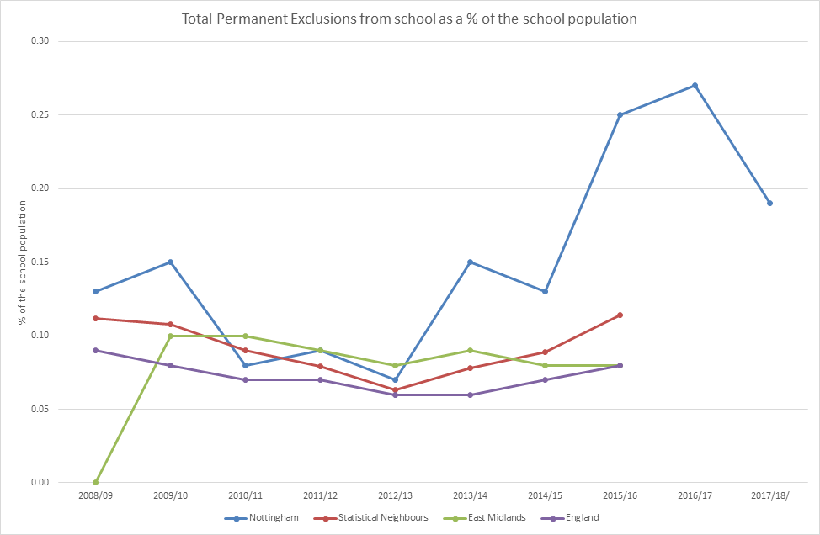

Under the current guidance, we can only charge excluding schools the statutory amount (relating to the formula funding and pro-rata to the end of financial year) unless we have a separate agreement with that school, such as the under a devolved AP funding model. Beyond that, the high needs budget picks up the cost until such a point that the pupil leaves education or is re-integrated into a mainstream school.

The revised devolved AP funding model is based on secondary schools having a place allocation or equivalent funding based on double the latest published national rate of secondary exclusions. At the time of writing, 10 out of 17 secondary schools have agreed to this model. The LA has no legally enforceable means to insist that the remaining schools participate or to charge them for the cost of their exclusions beyond the statutory amount.

As at the May census there were 263 pupils on roll at Denewood and Unity Learning Centres (22 KS2, 85 KS3, 156 KS4). As this number far exceeds the internal capacity of Denewood PRU (42 places) the majority of pupils are accessing their education in offsite alternative provision. The average cost paid for external AP in 2017/18 was in excess of £100 per day.

Since the hike in exclusions in 2015/16 the DSG reserve has been used each year to support budget pressures related to excluded pupils as follows; 2015/16 £1.6m, 2016/17 £2.5m, 2017/18 £2.4m 2018/19 £2.8m (budget estimate).

2.3 Schools Block transfer regulations

The Local Authority receives Dedicated Schools Grant allocations for 4 discrete blocks. The following diagram shows Nottingham’s 2018/19 indicative allocations.

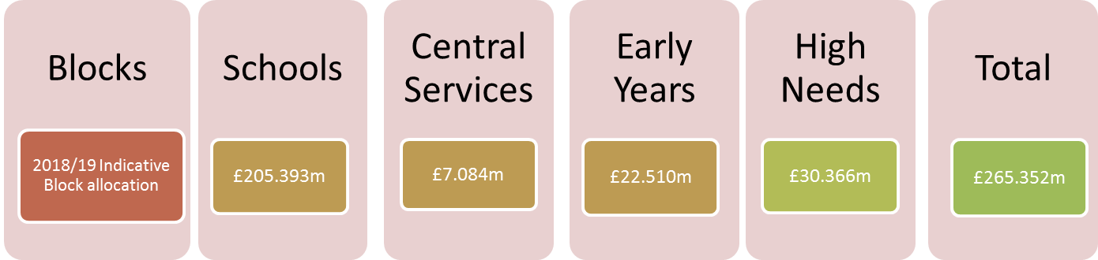

0.5% Block Transfer = £1.027m

- Schools Forum can approve a block transfer of up to 0.5% of the schools block. For Nottingham this equates to just over £1m.
- All schools must be consulted and Schools Forum should take into account the views of schools responding when deciding on whether to give their approval.
- A block transfer can only be agreed for 1 year at a time.
- LAs can submit an application to the Secretary of State for approval where the LA wishes to transfer more than 0.5% or proceed with a transfer even though Schools Forum have turned down a proposal.

3.0 Rationale for a Schools Block transfer

DSG reserves are running out. The remaining uncommitted balance on the DSG reserve currently stands at £3.138m.

We want to safeguard as much as possible of this balance for 2020/21 onwards when we may be operating under a “hard” national funding formula and lose the flexibility for a schools block transfer. Once this happens and our reserves are exhausted we will have no option to make cuts elsewhere in our high needs budgets to balance to our in-year high needs allocation.

This proposal will help safeguard existing provision and support for our most vulnerable pupils for as long as possible and allow us to retain enough of a cushion to make changes if necessary in a planned way.

This proposal aims to generate additional funding for the high needs budget to mitigate the risk of secondary exclusions over and above the level allowed for under the devolved AP model from non-participating schools.

If the secondary schools that have not signed up to the devolved AP model have similar numbers of permanent exclusions in the next 12 months as in the last 12 months, then there would be a funding shortfall of £0.3m in 2018/19 and £1.0m in 2019/20 compared to if they had all signed up.
Rather than funding the entire potential £1.38m shortfall from the remaining balance in the DSG reserve, the presented proposals seek to fund around £1m-£1.3m from a DSG block transfer in 2019/20.

4.0 Proposals

4.1 Proposal A (recommended)

Funding per pupil in the secondary phase would be cut by up to 1.5% per pupil in 2019/20. Subject to Secretary of State approval for a block transfer exceeding 0.5%, schools signed up to the devolved AP model would receive a 35% reimbursement through additional devolved funding.

4.1.1 Rationale

As the budget issue has predominantly arisen from exclusions in the secondary phase, this proposal is based around limiting the impact to secondary schools. Primary school budgets are unaffected. This proposal also seeks to reduce the impact on secondary schools participating in the devolved AP model by giving them a 35% reimbursement through additional devolved funding.

As all but 3 City schools are receiving protection through the Minimum Funding Guarantee (MFG) we will need to implement the change through reducing the MFG % as well as varying the secondary unit rates of funding. Based on current regulations, LA’s can set the MFG % between -1.5% and +0.5%.

It is highly unlikely that the Secretary of State would agree to a greater than 1.5% cut in funding per pupil. This is why we don’t think that an attempt to put a greater proportion of the impact on non-participating secondary schools would be viable (i.e. through a greater than 1.5% headline MFG cut and a greater than 35% reimbursement.)

4.1.2 Implications

This proposal would require Secretary of State approval to set the MFG at a different level for secondary schools in the city compared to primary schools.

This proposal would also require Secretary of State approval as it will involve a greater than 0.5% transfer. It is estimated that a 1.5% cut in secondary funding would generate a block transfer of about 0.79%. This is the percentage that would require approval. However, some of the funding transferred to high needs would be reimbursed to secondary schools participating in the devolved AP model through higher devolved allocations. The net effect would be around 0.62%. This would generate around £1.265m to mitigate the cost of exclusions in non-participating schools, potentially leaving around £0.115m to be funded from the DSG reserve.

If the Secretary of State refuses to approve our application for a greater than 0.5% transfer then we will be unable to differentiate between participating/non-participating schools. We would need to cut secondary funding uniformly for all schools at a level that would generate a block transfer that falls within the 0.5% that can be approved locally. It is estimated that this would equate to around a 0.75% cut in funding per pupil in secondary schools for 2019/20. This would generate just over £1m, potentially leaving around £0.350m to be funded from the DSG reserve. There is a very similar financial impact on schools participating in the devolved AP model under either scenario.

4.1.3 Impact on schools

We have modelled the impact of the proposals on individual schools by looking at what would have happened if we had implemented the proposals in 2018/19.

Schools are impacted differently according to size and the level of their baseline funding per pupil which varies according to the level of deprivation and other factors.

Individual school impact data is available online. By inputting your school 2018/19 passcode, you can view the estimated impact for your school. The spreadsheet shows:

- The approximate size and scale of a 1.5% funding cut – this is roughly the funding cut non-participating secondary schools would see to their budgets compared to 2018/19.
- The full impact when compared to a 0.5% funding increase – without the block transfer we would expect to be increasing funding by 0.5% in 2019/20 so this shows the impact of the full 2% swing.
- This is the full impact of the 2% swing on a per pupil basis so schools can apply this to a forecast of October 2018 pupil numbers for a more accurate estimate on the impact in 2019/20.
- This is the full impact but with the effect of the 35% reimbursement which would apply to schools that sign up to the devolved AP model.
- This is the approximate size and scale of a 0.75% funding cut compared to 2018/19.
- This is the full impact of a 0.75% funding cut when compared to a 0.5% funding increase, a 1.25% swing.
- This is the full impact of the 1.25% swing on a per pupil basis so schools can apply this to a forecast of October 2018 pupil numbers for a more accurate estimate on the impact in 2019/20.

Primary schools are unaffected under Proposal A.

4.2 Proposal B (fall-back option)

Under proposal B, all mainstream City schools would forego a funding increase of around 0.5% in 2019/20.

4.2.1 Rationale

Proposal B is required as a fall-back option, in the event the Secretary of State refuses permission for us to treat primary and secondary schools differently.

We would still wish to pursue a schools block transfer for the reasons outlined in Section 3.
4.2.2 Implications

The MFG for all mainstream schools would be set at 0%, meaning schools receiving MFG protection would have the same level of funding per pupil in 2019/20 as 2018/19.

This proposal is estimated to generate approximately £0.963m, meaning a further £0.417m would potentially need to be funded from the DSG reserve.

4.2.3 Impact on schools

Rather than seeing a funding increase of up to 0.5% per pupil in 2019/20, schools would have funding per pupil at about the same level as 2018/19.

The funding increase forgone would equate to on average £21 per pupil in the primary phase, varying by school according to how high their baseline funding per pupil is. The funding increase forgone in the secondary phase equates to on average £29 per pupil in the secondary phase.

The individual school impact spreadsheet available online shows an estimate of the potential funding increase in 2019/20 that individual schools will forgo as a result of this proposal. This is based on October 2017 pupil numbers. The per pupil amount is also shown so schools can apply this to their forecast of October 2018 pupil numbers for a more accurate estimate.

5.0 Longer term plan for managing within our high needs allocation

Schools Forum can only give approval for a one-off transfer of funding in 2019/20. For a number of reasons outlined below we anticipate the AP budget pressure reducing over time. We see the block transfer as an important measure to ensure we have sufficient breathing space to take decisions about high needs provision in a planned way with better information about the national picture and linking in to our long-term high needs strategy.

5.1 Collaborative working and early intervention strategies

A number of initiatives in partnership with schools and other agencies should help reduce pupil exclusions in the longer term:

- Multi-agency working via the exclusions/behaviour taskforce
- Routes to inclusion toolkit being embedded in primary phase including workshops and training
- Expansion of routes to inclusion to secondary phase
- Better management of transition for at risk pupils
- Exploration of models of “enhanced resource” for pupils with SEMH
5.2 High needs funding growth

Nottingham City is due to see significant increases over time in our high needs allocation under the national HN FF, eventually amounting to a £6.7m increase compared to our 2017/18 baseline. However, our gains are being capped at 3% per year and we have other high needs pressures to deal with. The DfE have not yet decided on the transitional capping/protection arrangements from 2020 onwards so we don’t know how long it will take us to see significant gains.

5.3 National policy changes on exclusions

The 2016 education white paper “Educational Excellence Everywhere” proposed that schools will eventually be responsible for the budget for AP, commissioning the provision and be accountable for the outcomes. The government is currently undertaking a review of exclusions which will report by the end of 2018. This may result in a national requirement for the AP element of the high needs funding allocation being devolved to schools.

5.4 DSG reserves as back stop

Until such a time as we see a reduction in the PRU/AP budget pressure resulting from the factors highlighted in paragraphs 5.1 to 5.3, we will use remaining DSG reserves to plug the gap. This proposal ought to allow us to retain sufficient DSG reserves to be able to meet the shortfall in 2020/21. By this point, we will have a better idea of our future high needs funding allocations linked to the next Government Spending Review and will give us time to make necessary changes to our high needs provision to balance the budget in a planned way.

Appendix A – National High Needs Funding Formula

1) Diagram outlining how the national high needs funding formula is calculated:

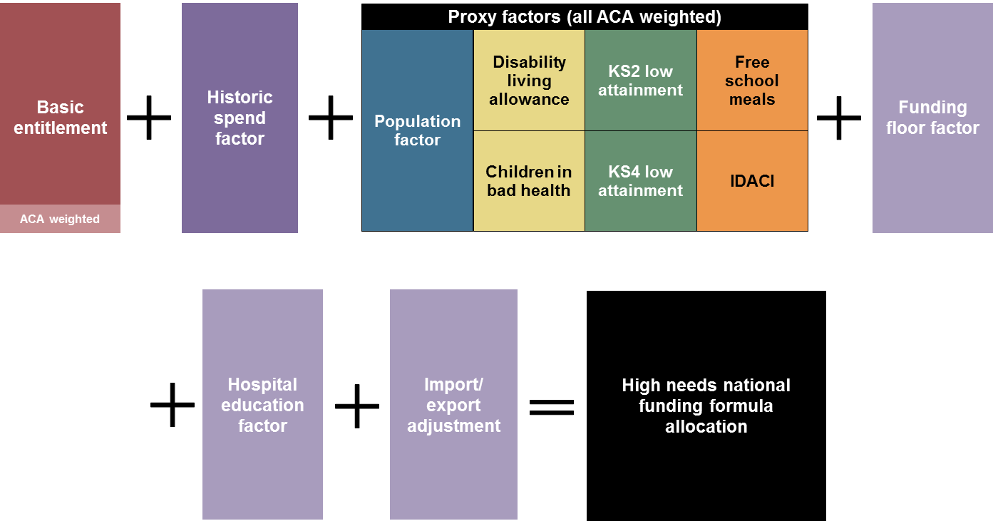

2) Table showing the weighting of the proxy factors, for SEN and AP elements:

