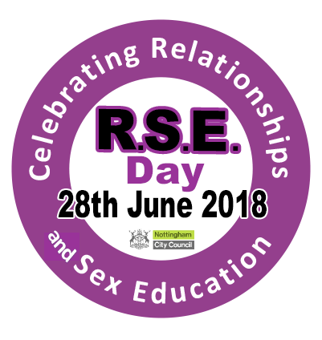

RSE Day at Loxley House – 28th June 2018

Lower foyer – DWP area – open access
RSE exhibition – learn more about what RSE is, why it is important, and what we are doing in the City to ensure every child receives their entitlement to effective RSE.

LB22 – Talks and workshops for NCC staff
You can sign up for these talks/workshops on the 28th June from 8am in LB22. Places will be allocated on a first come, first serve basis.
9.30am – The history of contraception (20 minutes)
9.50am – So you think you know about contraception? (30 minutes)
10.20am – How to talk to your child about growing up, relationships and sex (20 minutes)
10.40am – Break
11.00am – Take the opportunity to view our interactive displays and speak to the staff available
12.00 – 1.30pm – Drop in ‘So you wanted to ask’ – Dr Katie Boog will be on hand to answer all your questions on sex, contraception, Sexually Transmitted Infections, etc. Also an opportunity to look at the display materials.
1.45pm – 3.30pm – Take the opportunity to view our interactive displays and speak to the staff available
3.45pm – What is effective RSE? (20 minutes)
4.15pm – Using storybooks to explore diverse families (20 minutes)
5.00pm – Close

Displays in LB22 for NCC staff
LGBT inclusive RSE
Answering children’s questions about relationships, sex and growing up
Contraception
Reading books that explore relationships and families
What is RSE?

For more information please contact Catherine Kirk – Catherine.kirk@nottinghamcity.gov.uk

