MENU
General
Intro to CAMHS - https://www.youtube.com/watch?v=0Ulx6kkNidk
Intro to SHARP - https://www.youtube.com/watch?v=332oPCj4sCw
Sleep – have you got enough charge - https://www.youtube.com/watch?v=UNaoPkuJep0
Single Session Therapy - https://www.youtube.com/watch?v=9540BlbspVY
SHARP – Let’s talk about suicide - https://www.youtube.com/watch?v=kz-ZK54AeIY 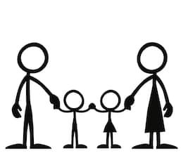 Aimed at CYP/ families
Staying connected - https://www.youtube.com/watch?v=Rps9UJxFxVs
5 fingers, 5 senses – (grounding technique) https://www.youtube.com/watch?v=26Z8Jr1vq5M
Just 5 more minutes – impact of gaming - https://www.youtube.com/watch?v=aemfl33Eh6E
How you doing - videos
Healthy Body Healthy Mind (Bio reg) - https://www.youtube.com/watch?v=PD8s8IVFuVY
Problem Solving - https://www.youtube.com/watch?v=IKHpUE6bTC8
Coping skills - https://www.youtube.com/watch?v=A7ICX8YmzNo
Worry Management - https://www.youtube.com/watch?v=oNyjXNNt9LM
Mood Management - https://www.youtube.com/watch?v=hH9-ch8C5Qw

Aimed at Parents
Just 5 more minutes – impact of gaming - https://www.youtube.com/watch?v=8cOhu85nf2U
Conflict resolution - https://www.youtube.com/watch?v=M_f6DXK7S9A
PACE – to be uploaded
Parenting anxiety – to be uploaded

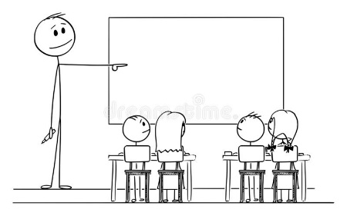 Aimed at Professionals
Trauma informed practice - https://www.youtube.com/watch?v=-fQ_sdX5cj8
5 fingers, 5 senses – (grounding technique) https://www.youtube.com/watch?v=26Z8Jr1vq5M
Amazing me (info) primary school - https://www.youtube.com/watch?v=JEmRjM7EeUE
Me:Source (info) secondary school - https://www.youtube.com/watch?v=FWskn1AxzuM
How you doing - audio
Biological Regulation - https://www.youtube.com/watch?v=8z242lyc7WQ
Problem solving - https://www.youtube.com/watch?v=s9HaB0JVHR4
Mood Management - https://www.youtube.com/watch?v=aopaPIvnK3U
Coping Skills - https://www.youtube.com/watch?v=ACyz8Kgf-3E
Worry Management - https://www.youtube.com/watch?v=ULIrHGEx-Mk

#NottinghamYouveBeenMissed podcasts (suitable for all)
Intro - https://www.youtube.com/watch?v=IdZq5uu23DE
What you said (survey feedback) - https://www.youtube.com/watch?v=95BEM5qZQJ0
Friendships - https://www.youtube.com/watch?v=CxAEaU1nXhY
Anxiety - https://www.youtube.com/watch?v=aTUY1bSb_GY
Routine - https://www.youtube.com/watch?v=zHRHv3XNOK0
Health Worries - https://www.youtube.com/watch?v=hWaHMF3P_PY
Emotionally based school avoidance - https://www.youtube.com/watch?v=GyDumLvq0y8
Power of Language (growth mindset) - https://www.youtube.com/watch?v=DuWtptz_k-Y
COMING SOON…. (for the return to school after half term)
Dealing with anxiety
Pebble Meditation
Dealing with Anxiety
3x 3 min meditation/ mindfulness
BA strategies
Distraction techniques

